**RoboMaster 2019 Robotics Competition**

**Season Schedule Template**

**2018.11**

**RoboMaster organizing committee reserves the right to edit this template and the right of final interpretation**

**Created by the RoboMaster organizing committee**

**Summary**

Introduce the document’s content and main points.

Annex：As a preliminary requirement of the competition, the organizing committee hopes that teams will utilize this planner for themselves effectively and not merely fill in the required content as a formality.

Producing five robots for the competition corresponds to producing five products, and it takes time and effort for a product to go through its cycle: design – research – prototyping – testing – iteration. Before this cycle even begins, careful analysis of the needs of the product user (robot operators), usage environment (the competition arena), functionality, cost, etc must be made.

We hope that teams will plan meticulously for the entire season in order to maximize returns with minimum resources used.

# 1. Competition Values

1. What makes RM different from other competitions?

2. What can teams learn from participating in RM?

3. What are the differences between the knowledge gained from taking part in RM and the knowledge taught in school? What is the relationship between the two?

Annex: This section should contain the team’s honest reflection on the competition’s values and not just be copy and pasted from the rules. We hope that teams will develop a deeper understanding of the competition’s values and culture, and through it, organize their teams better to fully utilize the competition as a platform for developing talent. You are more than welcome to use this section to write down any perceived inadequacies of the competition or suggestions for improving the competition, but we hope that such feedback will be given only after thoughtful reflection.

# 2. Project Analysis

**1. Standard Robot**

1）Analysis of robot’s requirements (functionality)

2）Main direction of improvement

3）Analysis of resources required (e.g. the sentry requires armor plate modules before it can be tested)

4）Estimation of man-hours required

|  |  |  |  |  |  |  |  |
| --- | --- | --- | --- | --- | --- | --- | --- |
| Standard Robot | Requirement | Direction of Improvement | Resources required and estimated time of delivery | Manpower estimation | Technical skills required | Time required (Units: half-months) | Funds required |
| Turret |  |  |  |  |  |  |  |
| Chassis |  |  |  |  |  |  |  |
| Firing mechanism |  |  |  |  |  |  |  |
| Rune power-up |  |  |  |  |  |  |  |
| Automatic firing |  |  |  |  |  |  |  |

Points to consider: ① Time estimations for uncertain projects?

② Do you have the right people for the job? (which team members have the potential to do it?)

③ What resources do you need?

④ Final acceptable deadlines (e.g. it is not very prudent for teams to aim to be able to only recognize handwritten digits just a day before the regionals)

⑤ Can tasks be completed in parallel?

**2. Hero Robot**

**3. Engineer Robot**

**4. Aerial Robot**

**5. Sentry Robot**

**6. Overall Schedule**

**7. Overall Manpower Estimation**（Explicitly state how many team members required and which ones）

**8. Overall Funds Required**

**9. Other Resources**

Annex: Although most teams already understand the different roles of the different robots, there are still some teams who are not quite sure about it. We hope that teams will solidify this understanding through the analysis conducted in this section.

In the past, some teams are overly ambitious and try to implement all robot functionalities at once, resulting in subpar performances on all fronts since no one project is allocated adequate resources. Therefore, we hope that teams will prioritize the functionalities they wish to implement according to the abilities and resources of the team.

In terms of scheduling, most teams do draft a timetable, but few teams do so in detail and come up with realistic project timelines, resulting in loose management. Many teams also do not recognize the importance of testing and fail to allocate time for testing (including operator training) and iterative modifications.

# 3. Team Organization

1. Team Structure

2. Job Responsibilities of Different Positions

3. Manpower Allocation (Position and Number of People)

Annex: Having good team organization allows sub-teams to keep each other on schedule, detect and solve problems together and motivate one another. Most teams will allocate manpower for different sub-teams of a robot according to the different areas of technical expertise, but these sub-teams do not usually interact with each other. The overall design direction is instead usually decided by the captain or a more senior team member. Such a structure results in a rigid allocation of resources and prevents the captain from being unable to direct the development of the robots from a macro-perspective.

We recommend the following team structure:

Organization of Research and Development

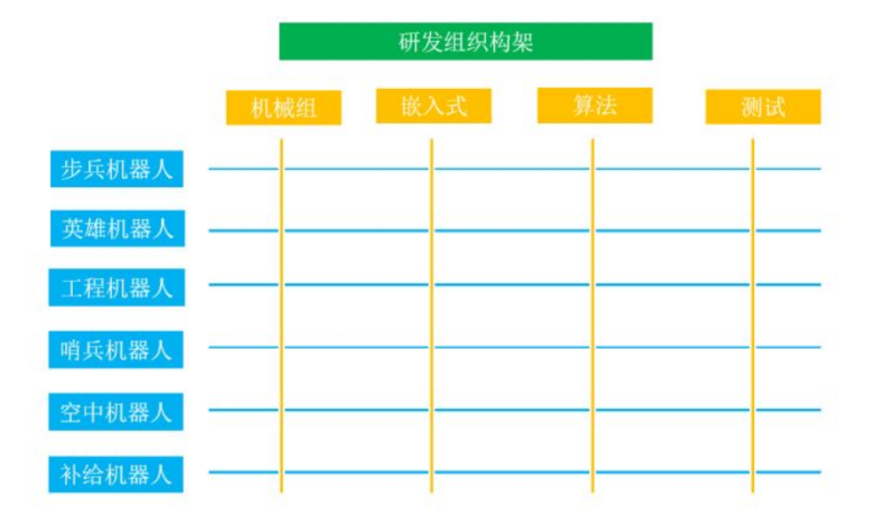

Mechanical Systems

Aerial Robot

Sentry Robot

Hero Robot Robot

Engineer Robot

Standard Robot

Testing

Algorithms

Embedded Systems

The yellow columns represent the different technical areas of expertise and the team is divided into 4 of them. Each sub-team in this category consists of all the team members who will be working on this area. Each sub-team would require a technical team lead who should not only have good management skills but also deep knowledge of the field. Technical team leads should make sure that there is room for personal development for all members in the sub-team.

Typically, there is no testing sub-team. Instead, team members from all areas of expertise take on the task of testing together. This includes module testing, full testing, combat testing etc. The testing team should have the final verdict on whether a feature is completed or not and will most likely serve as the robot operators as well.

The blue rows represent the different types of robots. We recommend designating a “product manager” for each robot project. The product manager should be a senior member with a broad range of knowledge in mechanical, hardware and software systems and the ability to prioritize features according to competition requirements. The captain and different product managers should convene and decide upon the project requirements for each robot. Subsequently, the product managers should convey these goals to their project teams. The product managers would also have to arrange for the appropriate manpower with the respective technical team leads. Finally, a project plan will be drafted and the responsibility of supervising the project will be handed over to the team’s overall project manager.

An example for consideration: in every year’s RoboMaster competition, the role of the standard robot usually does not change much. As such, it is a robot that requires iterative design improvements. On the other hand, the hero robot usually has major changes to its role and structure every year, instead requiring major reworks and redevelopments. Hence, each project would have different manpower requirements at different times of the year and the respective product managers must discuss and agree on resource allocation.

The teacher-mentor, captain and overall project manager should manage overall team structure and resource allocation. Each person can take on more than one role of technical team lead, product manager, captain or project manager, but teams should take care not to overload individuals with these duties.

The emphasis is that team organization is not rigid. When projects meet with difficulties, the technical team leads and product managers should reallocate manpower resources accordingly based on the project’s priority and requirements. While the captain should have the final decision-making power over the project manager, technical team leads and product managers, these managers should also have the ability to veto the decisions of an irresponsible captain. In order to achieve the goals of the team and solve problems, team members should focus on the tasks at hand instead of personal issues. Team members should not view vetoing poor decisions made by superiors as inappropriate and should understand that every individual has his flaws, and that not everyone is suited for a particular role. A team member who is not suited to be captain can still make huge contributions to a team even without the position.

As for teams with fewer members, the organization described above can still be used for reference. Although the team might not have enough people right now, you should prepare for organizing a complete team in the next year and aim to establish your team as a reputable student organization in your school.

# 4. Sharing of Knowledge

**1. Platforms for Sharing Knowledge**

1）What knowledge sharing platforms are there in the team?

2）Process of documentation and handing down knowledge

**2. New Member Training Plan**

1）Level of Expertise of Current Members（technical expertise, year of study）

2）Desired Team Member Expertise（After analysis of the team’s planned projects, what kind of technical expertise does the team need? ）

3）Training Plan (Who is being trained? Do they need practice? What is being used to teach them? What is the schedule of training?)

Annex: Robotics competitions are not just ad-hoc events, they require periods of consolidation and passing on of knowledge down the years. All teams recognize the importance of handing down knowledge, but in focusing all their resources on development, many teams fail to make proper documentation or train the junior members properly. The benefit of proper documentation is self-evident, and teams should cultivate the habit of regular documentation. Perhaps this practice could start with the captain, project manager or other core team members, where they lead by example and properly document a different module every week.

New team members should be instructed appropriately and rigorously. If new members are not trained properly, there could be asymmetric working relationships and responsibilities between old and new members in the future. Usually, new team members are trained through simple projects that enable them to familiarize themselves with new technical knowledge. Some teams spoon-feed their new members too much, resulting in the new members overly relying on their seniors. Conversely, other teams design overly complicated training projects and provide little guidance, resulting in new members losing their motivation to continue learning. The training procedure for new members is also an important part of the team and should be iteratively improved on every year as well.

# 5. Audit System

1. Each robot’s project timeline and deliverable targets for each period (e.g. mechanical systems: concept? 3D model? Blueprint? Prototype verification?)

2. Manpower requirements for each period – in detail, which individual members are required for which projects?

3. Review process

4. Progress tracking

5. Testing process

Annex: From experience, many teams do not value the review process, or do not do so rigorously. We recommend each robot undergo the following processes during its initial design period: (1) Confirm the role of each robot after researching past year conditions and careful analysis (2) Decide upon appropriate technical goals based on the different roles of each robot (3) Design the projects required to meet these goals and then finally dividing the tasks into the various disciplines of mechanical systems, embedded systems, algorithms etc. Teams should hold a review meeting to appraise each of the various projects and their risks. Of course, not everyone has to have an equal say in the meeting – for example, a person in charge of a project could have more voting power in decisions regarding that project. We hope that teams would consolidate the results of the meeting in a document and have it saved on the team’s common resource repository.

The result of ignoring the testing process is that robots become highly unstable and unreliable. A complete testing process should consist of the following procedures:

Module testing: test whether modules are operationally stable within the scope of their individual operations

Full testing: Integrate the individual modules into the complete robot system and test the stability of the entire robot according to its design requirements

Combined testing: Test whether the simultaneous operation of multiple robots is stable according to competition rules and team strategy. At the same time, simulate and test team strategy.

# 6. Resource Management

1. Funds (Received from the school? Other sources?)

2. Tools and equipment owned by the team

3. Externally available tools and equipment

4. Manpower resources (assignable workload, how much time can this member commit to the team?)

5. Officially provided resources and components

# 7. Publicity/ Sponsorship Plan

1. Publicity plan

2. Sponsorship plan

1）Do we need sponsors?

2）Benefits the team can bring to sponsors（Negotiation weight）

3）Potential sponsorship sources

4）Execution

Annex: We hope that team captains will value these non-technical aspects of the competition and provide a reasonable plan of action.